National University of Computer and Emerging Sciences



Lab 05

COAL

|  |  |
| --- | --- |
| Name | Muhammad Zain |
| Roll No. | 19F-0228 |
| LAB INSTRUCTOR | Mr Abuzar Ghafari |
| Semester | Fall 2020 |

Task 1

# **Source Code**

*; Author: Muhammad Zain*

; Program Name: Task 1 letter grading

; Program Description: .IF directive example

; Date: 04/11/2000

INCLUDE Irvine32.inc

.data

;==============================================================

;=====Grading Policy===========================================

Letter_grade1 byte " Grade A",0 ;90 to 100 A

Letter_grade2 byte " Grade B",0 ;80 to 89 B

Letter_grade3 byte " Grade C",0 ;70 to 79 C

Letter_grade4 byte " Grade D",0 ;60 to 69 D

Letter_grade5 byte " Grade F",0 ;0 to 59 F

;=============================================================

;=======Validation Messages===================================

Input_Msg byte " Input your Number between 0 to 100 to get the Grade",0

Invalid_Msg byte " Invalid Input ,Please input again ",0

;==============================================================

.code

main PROC

mov edx,offset Input_Msg

call writeString

call crlf

call readint

;=============Validation loop==================================

.while (eax < 0 || eax >100)

mov edx,offset Invalid_Msg

call writeString

call crlf

call readint

.endw

;===============================================================

.if (eax >89);================== A grade

mov edx,offset letter_grade1

call writeString

.elseif (eax >79);============= B grade

mov edx,offset letter_grade2

call writeString

.elseif (eax >69);============= C grade

mov edx,offset letter_grade3

call writeString

.elseif (eax >59);============= D grade

mov edx,offset letter_grade4

call writeString

.else ;=====================F grade

mov edx,offset letter_grade5

call writeString

.endif

call crlf

call WaitMsg

exit

main ENDP

END main

# **Snip**

Task 2

# **Source Code**

*; Author: Muhammad Zain*

; Program Name: Task 2 gates

; Program Description: gates

; Date: 04/11/2000

INCLUDE Irvine32.inc

.data

;=============== menu ===============================

menu_1 byte "Enter 1 for AND Operation ", 0

menu_2 byte "Enter 2 for OR Operation ", 0

menu_3 byte "Enter 3 for NOT Operation ", 0

menu_4 byte "Enter 4 for XOR Operation ", 0

menu_5 byte "Enter 5 to EXIT ", 0

;========================================================

;=========== Input Values================================

value1 db "Enter Value_1 = ",0

value2 db "Enter Value_2 = ",0

Answer dword ?

;========= validation ====================================

Validation_msg byte "Invalid Input enter again ",0

;=========================================================

enter_again byte " Input again from the above menu ", 0

;========================================================

.code

main PROC

;.REPEAT

mov edx,offset menu_1 ;======= And operation message

call writestring

call crlf

mov edx,offset menu_2 ;======= or operation message

call writestring

call crlf

mov edx,offset menu_3 ;======= xor operation message

call writestring

call crlf

mov edx,offset menu_4 ;======= not operation message

call writestring

call crlf

mov edx,offset menu_5 ;======= exit operation message

call writestring

call crlf

;=======Taking Input and validation ========================================

call readint

.while(eax > 5 || eax <1)

mov edx,offset Validation_msg

call writestring

call readint

.endw

;============================================================================

;============================================================================

.while (eax !=5)

.if (eax ==1)

call AND_OP

mov Answer,eax

call writehex

.elseif (eax ==2)

call OR_OP

mov Answer,eax

call writehex

.elseif(eax ==3)

call NOT_OP

mov Answer,eax

call writehex

.elseif (eax ==4)

call XOR_OP

mov Answer,eax

call writehex

.endif

call crlf

mov edx,offset enter_again

call writestring

call crlf

call readint

.endw

exit

main ENDP

;================================= And Function =================================

AND_OP PROC

call crlf

mov edx,offset value1

call writestring

call readhex

mov ebx,eax

mov edx,offset value2

call writestring

call readhex

AND eax,ebx

ret

AND_OP ENDP

;================================= OR Function =================================

OR_OP PROc

call crlf

mov edx,offset value1

call writestring

call readhex

mov ebx,eax

mov edx,offset value2

call writestring

call readhex

OR eax,ebx

ret

call crlf

OR_OP ENDP

;================================= NOt Function =================================

NOT_OP PROC

call crlf

mov edx,offset value1

call writestring

call readhex

NOT eax

ret

call crlf

NOT_OP ENDP

;================================= xor Function =================================

XOR_OP PROC

call crlf

mov edx,offset value1

call writestring

call readhex

mov ebx,eax

mov edx,offset value2

call writestring

call readhex

XOR eax,ebx

ret

call crlf

XOR_OP ENDP

END main

# **Snip:**

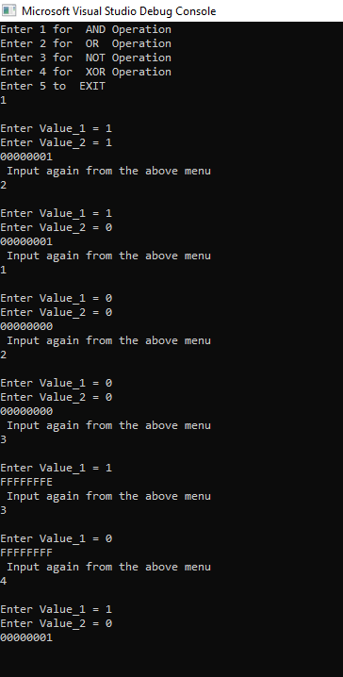

Task 3

# **Source Code**

*; Author: Muhammad Zain*

; Program Name: Task 3

; Program Description: palindrome

; Date: 04/11/2000

INCLUDE Irvine32.inc

.data

prompt1 byte "Input the string to check wheter it is Palindrome or not ",0

prompt2 byte "yes, it is Palindrome",0

prompt3 byte "No, it is not Palindrome",0

;=============================================================

;=============================================================

;Initializing Array with 0 and reverse array to match

getString byte 50 dup (0)

reverseString byte 50 dup(? )

stringCounter dword ?

;bool yes or no

is_Palindrome byte ?

TRUE = 1

FALSE = 0

.code

main PROC

;print main message

mov edx,offset prompt1

call writestring

call crlf

;=============================================================

;=============================================================

;taking input of string

mov edx,offset getString

mov ecx,sizeof getString

call readstring

mov stringCounter ,eax

mov ecx,stringCounter

;=============================================================

;=============================================================

;pushing the main string in stack

mov esi ,0

L1:

movzx eax,getString[esi]

push eax

inc esi

loop L1

;=============================================================

;=============================================================

;Pushing reverse string

mov esi ,0

mov ecx,stringCounter

l2:

pop eax

mov reverseString[esi], al

inc esi

loop l2

;calling function

call check_Palindrome

;checking values

.if( is_Palindrome== FALSE)

mov edx,offset prompt3

call writestring

call crlf

.else

mov edx,offset prompt2

call writestring

call crlf

.endif

exit

main ENDP

;=============================================================

;=============================================================

;first we take the user string

;then we push in stack for the sake of reversing

;then we reverse it

;save it another string

;compare both string

check_Palindrome PROC

mov esi, 0

mov ecx, stringCounter

mov is_Palindrome, TRUE

checkLoop:

mov al,reverseString[esi]

.if(getString[esi]==al)

mov is_Palindrome,TRUE

.else

mov is_Palindrome,FALSE

inc esi

.endif

ret

check_Palindrome ENDP

END mainENDP

END main

# **Snip**

